Huỳnh Ngọc Phúc _ 1150070035
Máy 36
Lab 6: Layout and app
Phần Bài Tập
Bước 1: Ta mở Android Studio, click vào New Project tích vào Empty Views Activity (hoặc Empty Activity).
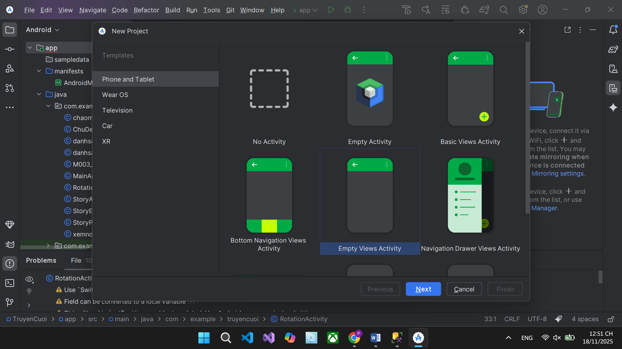
Ta đặt là ProjectLab 6 như hình
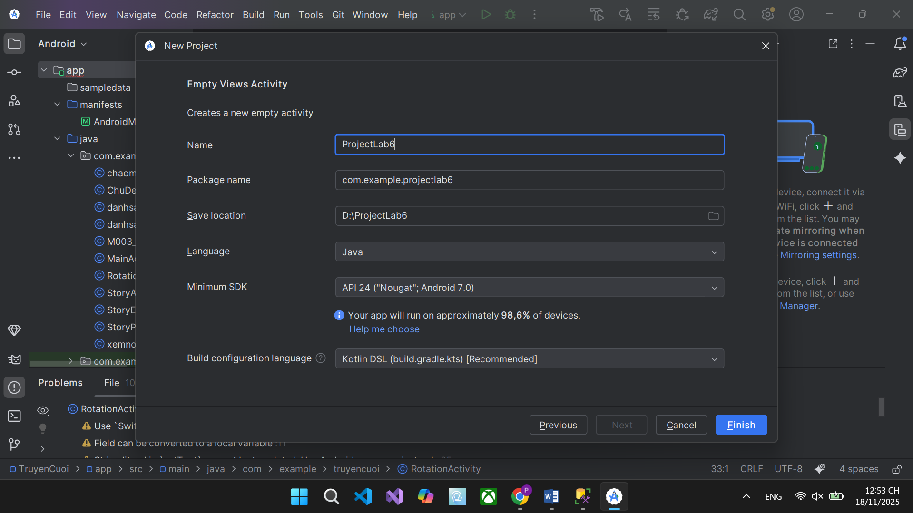
Bước 2: Ta tạo giao diện từ file app/src/main/res/layout/activity_main.xml, ta xóa file giao diện cũ và dán đoạn code mới vào bên dưới
<?xml version="1.0" encoding="utf-8"?>
<LinearLayout xmlns:android="http://schemas.android.com/apk/res/android"
android:orientation="vertical"
android:padding="16dp"
android:layout_width="match_parent"
android:layout_height="match_parent">
<TextView
android:text="Số tiền cần đổi"
android:textStyle="bold"
android:layout_width="wrap_content"
android:layout_height="wrap_content"/>
<EditText
android:id="@+id/edtAmount"
android:inputType="numberDecimal"
android:hint="Nhập số tiền..."
android:layout_width="match_parent"
android:layout_height="wrap_content"/>
<TextView
android:text="Từ tiền tệ"
android:layout_marginTop="12dp"
android:layout_width="wrap_content"
android:layout_height="wrap_content"/>
<Spinner
android:id="@+id/spFrom"
android:layout_width="match_parent"
android:layout_height="wrap_content"/>
<TextView
android:text="Sang tiền tệ"
android:layout_marginTop="12dp"
android:layout_width="wrap_content"
android:layout_height="wrap_content"/>
<Spinner
android:id="@+id/spTo"
android:layout_width="match_parent"
android:layout_height="wrap_content"/>
<Button
android:id="@+id/btnConvert"
android:text="Đổi tiền"
android:layout_marginTop="16dp"
android:layout_width="match_parent"
android:layout_height="wrap_content"/>
<TextView
android:id="@+id/tvResult"
android:text="Kết quả sẽ hiển thị tại đây"
android:textStyle="bold"
android:textSize="16sp"
android:layout_marginTop="16dp"
android:layout_width="match_parent"
android:layout_height="wrap_content"/>
</LinearLayout>

Bước 3: Ta thêm mảng tiền tệ vào file app/src/main/res/values/strings.xml, ta chèn thêm string-array
<resources>
<string name="app_name">ProjectLab6</string>
<string-array name="currencies">
<item>VND</item>
<item>USD</item>
<item>EUR</item>
<item>JPY</item>
<item>GBP</item>
<item>AUD</item>
</string-array>
</resources>

Bước 4: Ta xử lý code logic chuyển đổi tại file MainActivity.java
package com.example.projectlab6; // đổi cho khớp với package của bạn
import android.os.Bundle;
import android.text.TextUtils;
import android.widget.ArrayAdapter;
import android.widget.Button;
import android.widget.EditText;
import android.widget.Spinner;
import android.widget.TextView;
import android.widget.Toast;
import androidx.appcompat.app.AppCompatActivity;
import java.text.DecimalFormat;
public class MainActivity extends AppCompatActivity {
private EditText edtAmount;
private Spinner spFrom, spTo;
private Button btnConvert;
private TextView tvResult;
private static final double[][] RATES = {
// VND USD EUR JPY GBP AUD
/*VND*/ {1.0, 0.000039, 0.000036, 0.0061, 0.000031, 0.000058},
/*USD*/ {25500, 1.0, 0.92, 155.0, 0.81, 1.48},
/*EUR*/ {27700, 1.09, 1.0, 168.0, 0.88, 1.61},
/*JPY*/ {165.0, 0.0065, 0.0059, 1.0, 0.0052, 0.0096},
/*GBP*/ {31700, 1.23, 1.14, 193.0, 1.0, 1.83},
/*AUD*/ {17300, 0.68, 0.62, 104.0, 0.55, 1.0}
};
private final DecimalFormat formatter = new DecimalFormat("#,##0.####");
@Override
protected void onCreate(Bundle savedInstanceState) {
super.onCreate(savedInstanceState);
setContentView(R.layout.activity_main);
mapViews();
setupSpinners();
bindActions();
}
private void mapViews() {
edtAmount = findViewById(R.id.edtAmount);
spFrom = findViewById(R.id.spFrom);
spTo = findViewById(R.id.spTo);
btnConvert = findViewById(R.id.btnConvert);
tvResult = findViewById(R.id.tvResult);
}
private void setupSpinners() {
ArrayAdapter<CharSequence> adapter = ArrayAdapter.createFromResource(
this, R.array.currencies, android.R.layout.simple_spinner_item
);
adapter.setDropDownViewResource(android.R.layout.simple_spinner_dropdown_item);
spFrom.setAdapter(adapter);
spTo.setAdapter(adapter);
spFrom.setSelection(0);
spTo.setSelection(1);
}
private void bindActions() {
btnConvert.setOnClickListener(v -> convert());
}
private void convert() {
String amountStr = edtAmount.getText().toString().trim();
if (TextUtils.isEmpty(amountStr)) {
edtAmount.setError("Hãy nhập số tiền");
return;
}
double amount;
try {
amount = Double.parseDouble(amountStr);
} catch (NumberFormatException e) {
edtAmount.setError("Giá trị không hợp lệ");
return;
}
if (amount < 0) {
edtAmount.setError("Số tiền phải >= 0");
return;
}
int from = spFrom.getSelectedItemPosition();
int to = spTo.getSelectedItemPosition();
if (from < 0 || to < 0 || from >= RATES.length || to >= RATES.length) {
Toast.makeText(this, "Lựa chọn tiền tệ không hợp lệ", Toast.LENGTH_SHORT).show();
return;
}
double rate = RATES[from][to];
double result = amount * rate;
String fromCode = spFrom.getSelectedItem().toString();
String toCode = spTo.getSelectedItem().toString();
tvResult.setText(
String.format("%s %s = %s %s",
formatter.format(amount), fromCode,
formatter.format(result), toCode)
);
}
}

Bước 5: Sau khi khởi chạy, ta nhập 10000 từ tiền tệ VND sang tiền tệ USD sẽ thành là 0.39 USD
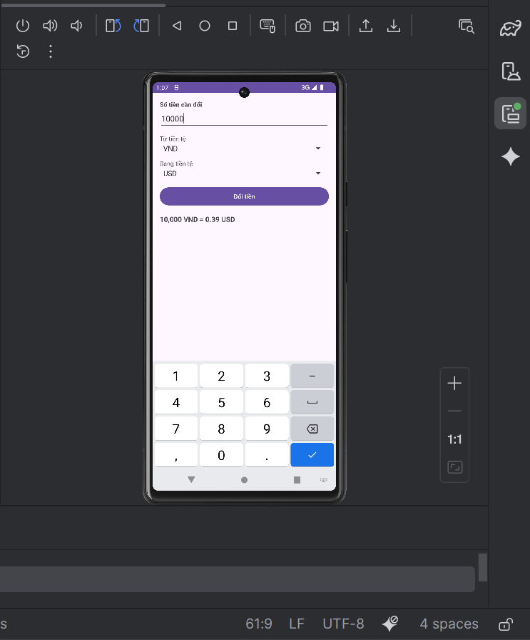
Phần Luyện Tập
Bước 1: Dựa theo dự án trên, ta thêm dưới nút “Đổi tiền” để chuyển tab sang bài tập khác
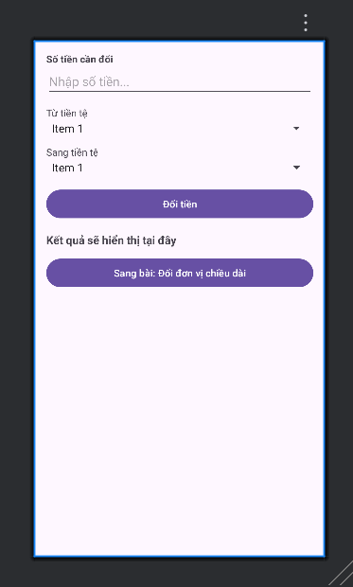
Bước 2: Ta khai báo mảng đơn vị chiều dài, chèn thêm dưới string-array currencies trong string.xml
<string-array name="length_units">
<item>Hải lý</item>
<item>Dặm</item>
<item>Km</item>
<item>Lý</item>
<item>Met</item>
<item>Yard</item>
<item>Foot</item>
<item>Inch</item>
</string-array>

Bước 3: Ta tạo layout cho màn đổi chiều dài từ file activity_length.xml
<?xml version="1.0" encoding="utf-8"?>
<LinearLayout xmlns:android="http://schemas.android.com/apk/res/android"
android:orientation="vertical"
android:padding="16dp"
android:layout_width="match_parent"
android:layout_height="match_parent">
<LinearLayout
android:orientation="horizontal"
android:layout_width="match_parent"
android:layout_height="wrap_content">
<EditText
android:id="@+id/edtValue"
android:layout_weight="1"
android:layout_width="0dp"
android:layout_height="wrap_content"
android:hint="Nhập giá trị..."
android:inputType="numberDecimal" />
<Spinner
android:id="@+id/spUnit"
android:layout_marginStart="8dp"
android:layout_width="120dp"
android:layout_height="wrap_content" />
</LinearLayout>
<TextView
android:text="Tương đương với"
android:textStyle="bold"
android:textColor="#00796B"
android:background="#B2DFDB"
android:padding="8dp"
android:layout_marginTop="12dp"
android:layout_width="match_parent"
android:layout_height="wrap_content" />
<ListView
android:id="@+id/lvResults"
android:dividerHeight="1dp"
android:layout_width="match_parent"
android:layout_height="0dp"
android:layout_weight="1" />
<Button
android:id="@+id/btnBack"
android:text="Quay về bài: Đổi tiền tệ"
android:layout_marginTop="8dp"
android:layout_width="match_parent"
android:layout_height="wrap_content"/>
</LinearLayout>

Bước 4: Tạo file LengthActivity.java để code logic
package com.example.projectlab6;
import android.os.Bundle;
import android.text.Editable;
import android.text.TextUtils;
import android.text.TextWatcher;
import android.widget.ArrayAdapter;
import android.widget.Button;
import android.widget.EditText;
import android.widget.ListView;
import android.widget.Spinner;
import android.widget.Toast;
import androidx.appcompat.app.AppCompatActivity;
import com.example.projectlab6.R;
import java.text.DecimalFormat;
import java.util.ArrayList;
import java.util.List;
public class LengthActivity extends AppCompatActivity {
private EditText edtValue;
private Spinner spUnit;
private ListView lvResults;
private Button btnBack;
private static final double[][] LEN = {
/* Hải lý Dặm Km Lý Met Yard Foot Inch */
/*Hải lý*/ { 1.0, 1.15077945, 1.85200000, 20.2537183, 1852.00000, 2025.37183, 6076.11549, 72913.38583 },
/*Dặm */ { 0.86897624, 1.0, 1.60934400, 17.6000000, 1609.34400, 1760.00000, 5280.00000, 63360.00000 },
/*Km */ { 0.53995680, 0.62137119, 1.0, 10.9361330, 1000.00000, 1093.61330, 3280.83990, 39370.07874 },
/*Lý */ { 0.04937365, 0.05681818, 0.09144000, 1.0, 91.44000, 100.00000, 300.00000, 3600.00000 },
/*Met */ { 0.00053996, 0.00062137, 0.00100000, 0.01093610, 1.0, 1.09361330, 3.28084000, 39.37007874 },
/*Yard */ { 0.00049374, 0.00056818, 0.00091440, 0.01000000, 0.91440000, 1.0, 3.00000000, 36.00000000 },
/*Foot */ { 0.00016458, 0.00018939, 0.00030480, 0.00333333, 0.30480000, 0.33333333, 1.0, 12.00000000 },
/*Inch */ { 0.00001371, 0.00001578, 0.00002540, 0.00027778, 0.02540000, 0.02777778, 0.08333333, 1.0 }
};
private final DecimalFormat df = new DecimalFormat("#,##0.####");
@Override
protected void onCreate(Bundle savedInstanceState) {
super.onCreate(savedInstanceState);
setContentView(R.layout.activity_length);
mapViews();
setupSpinner();
setupEvents();
renderList();
}
private void mapViews() {
edtValue = findViewById(R.id.edtValue);
spUnit = findViewById(R.id.spUnit);
lvResults = findViewById(R.id.lvResults);
btnBack = findViewById(R.id.btnBack);
}
private void setupSpinner() {
ArrayAdapter<CharSequence> adapter = ArrayAdapter.createFromResource(
this, R.array.length_units, android.R.layout.simple_spinner_item
);
adapter.setDropDownViewResource(android.R.layout.simple_spinner_dropdown_item);
spUnit.setAdapter(adapter);
spUnit.setSelection(1); // Dặm
}
private void setupEvents() {
edtValue.addTextChangedListener(new TextWatcher() {
@Override public void beforeTextChanged(CharSequence s, int start, int count, int after) { }
@Override public void onTextChanged(CharSequence s, int start, int before, int count) { renderList(); }
@Override public void afterTextChanged(Editable s) { }
});
spUnit.setOnItemSelectedListener(new android.widget.AdapterView.OnItemSelectedListener() {
@Override public void onItemSelected(android.widget.AdapterView<?> parent, android.view.View view, int position, long id) { renderList(); }
@Override public void onNothingSelected(android.widget.AdapterView<?> parent) { }
});
btnBack.setOnClickListener(v -> finish());
}
private void renderList() {
String valStr = edtValue.getText().toString().trim();
double value = 0.0;
if (!TextUtils.isEmpty(valStr)) {
try {
value = Double.parseDouble(valStr);
if (value < 0) {
Toast.makeText(this, "Giá trị phải >= 0", Toast.LENGTH_SHORT).show();
return;
}
} catch (NumberFormatException e) {
Toast.makeText(this, "Giá trị không hợp lệ", Toast.LENGTH_SHORT).show();
return;
}
}
int from = spUnit.getSelectedItemPosition();
if (from < 0 || from >= LEN.length) return;
String[] units = getResources().getStringArray(R.array.length_units);
List<String> rows = new ArrayList<>();
for (int to = 0; to < LEN.length; to++) {
double res = value * LEN[from][to];
rows.add(df.format(res) + " — " + units[to]);
}
ArrayAdapter<String> listAdapter = new ArrayAdapter<>(this, android.R.layout.simple_list_item_1, rows);
lvResults.setAdapter(listAdapter);
}
}

Bước 5: Ta khai báo Activity mới tạo trong AndroidManifest.xml
<activity android:name=".LengthActivity" android:exported="false" />

Bước 6: Sau khi chạy dự án, nó sẽ có nút chuyển từ bài chuyển đổi tiền tệ sang đổi đơn vị chiều dài. Khi nhập vào 1000 chọn “Dặm” thì bên dưới sẽ hiện thị các đơn vị chiều dài tương ứng
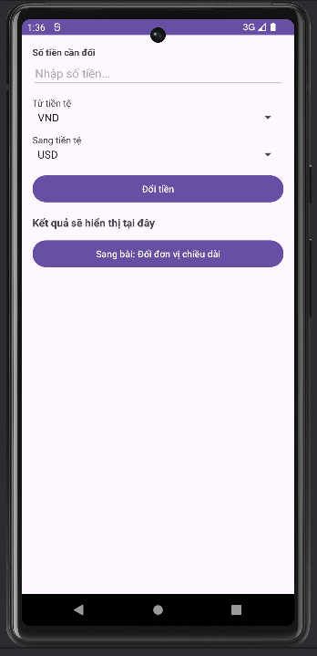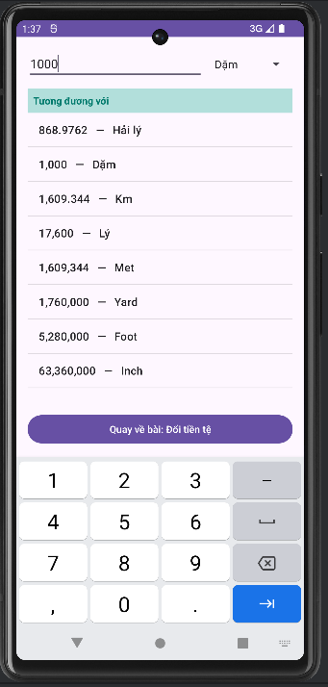
LAB 7: Layout and application
Phần Bài Tập
Bài tập 1:
Bước 1: Ta tạo dự án mới đặt tên là ProjectLab7
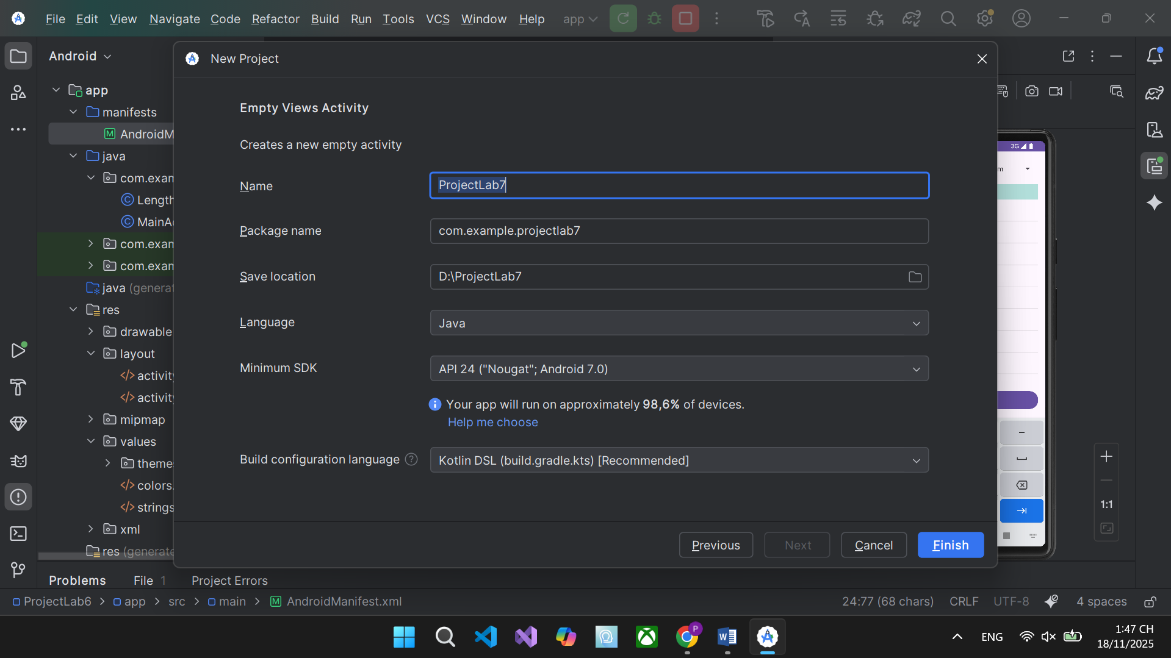
Bước 2: Ta tạo màu và text trong res/values/colors.xml và res/values/strings.xml
- File colors.xml
<resources>
<color name="white">#FFFFFFFF</color>
<color name="black">#FF000000</color>
<color name="bg">#FFF5F7FA</color>
<color name="sel_normal">#FF26C6DA</color> <!-- teal -->
<color name="sel_pressed">#FF0097A7</color>
<color name="sel_text">#FFFFFFFF</color>
<color name="sel_disabled_bg">#FFFFEB3B</color> <!-- yellow -->
<color name="sel_disabled_text">#FF1B1B1B</color>
<color name="round_bg">#FFE0E0E0</color>
<color name="round_text">#FF1B1B1B</color>
<color name="grad_start">#FF00BCD4</color>
<color name="grad_end">#FF00796B</color>
<color name="grad_stroke">#FF004D40</color>
<color name="shape_red_normal">#FFE57373</color>
<color name="shape_red_pressed">#FFEF5350</color>
<color name="shape_red_stroke">#FFB71C1C</color>
</resources>
- File strings.xml
<resources>
<string name="app_name">ProjectLab7</string>
<string name="btn_label">Custom Button</string>
<string name="col_left">Selectors</string>
<string name="col_right">Shapes+Selectors</string>
<string name="btn_colored_selector">COLORED SELECTOR</string>
<string name="btn_colored_selector_disabled">COLOR SELECTOR\nDISABLED</string>
<string name="btn_round_shape">ROUND SHAPE</string>
<string name="btn_shape_gradient">SHAPE WITH GRADIENT</string>
<string name="btn_selector_shape">SELECTOR SHAPE</string>
</resources>

Bước 3: Ta tạo nền hình cho cột bên trái, tạo 4 file drawable
- res/drawable/btn_colored_normal.xml
<shape xmlns:android="http://schemas.android.com/apk/res/android">
<corners android:radius="8dp"/>
<solid android:color="@color/sel_normal"/>
<padding android:left="16dp" android:top="10dp" android:right="16dp" android:bottom="10dp"/>
</shape>

- res/drawable/btn_colored_pressed.xml
<shape xmlns:android="http://schemas.android.com/apk/res/android">
<corners android:radius="8dp"/>
<solid android:color="@color/sel_pressed"/>
<padding android:left="16dp" android:top="10dp" android:right="16dp" android:bottom="10dp"/>
</shape>

- res/drawable/btn_colored_selector.xml
<selector xmlns:android="http://schemas.android.com/apk/res/android">
<item android:state_enabled="false" android:drawable="@drawable/btn_disabled_bg"/>
<item android:state_pressed="true" android:drawable="@drawable/btn_colored_pressed"/>
<item android:drawable="@drawable/btn_colored_normal"/>
</selector>

- res/drawable/btn_disabled_bg.xml
<shape xmlns:android="http://schemas.android.com/apk/res/android">
<corners android:radius="8dp"/>
<solid android:color="@color/sel_disabled_bg"/>
<stroke android:width="1dp" android:color="#40000000"/>
<padding android:left="16dp" android:top="10dp" android:right="16dp" android:bottom="10dp"/>
</shape>

Bước 4: Ta tạo nền hình cho cột bên phải
- Ta tạo nút tròn ở file res/drawable/btn_round_shape.xml
<shape xmlns:android="http://schemas.android.com/apk/res/android" android:shape="oval">
<size android:width="120dp" android:height="48dp"/>
<solid android:color="@color/round_bg"/>
<stroke android:width="1dp" android:color="#33000000"/>
</shape>

- Ta tạo nút gradient viền res/drawable/btn_shape_gradient.xml
<shape xmlns:android="http://schemas.android.com/apk/res/android">
<corners android:radius="10dp"/>
<gradient
android:startColor="@color/grad_start"
android:endColor="@color/grad_end"
android:angle="0"/>
<stroke android:width="2dp" android:color="@color/grad_stroke"/>
<padding android:left="16dp" android:top="10dp" android:right="16dp" android:bottom="10dp"/>
</shape>

- Ta tạo nút Selector đỏ ở các file sau
res/drawable/btn_shape_red_normal.xml
<shape xmlns:android="http://schemas.android.com/apk/res/android">
<corners android:radius="10dp"/>
<solid android:color="@color/shape_red_normal"/>
<stroke android:width="2dp" android:color="@color/shape_red_stroke"/>
<padding android:left="16dp" android:top="10dp" android:right="16dp" android:bottom="10dp"/>
</shape>

res/drawable/btn_shape_red_pressed.xml
<shape xmlns:android="http://schemas.android.com/apk/res/android">
<corners android:radius="10dp"/>
<solid android:color="@color/shape_red_pressed"/>
<stroke android:width="2dp" android:color="@color/shape_red_stroke"/>
<padding android:left="16dp" android:top="10dp" android:right="16dp" android:bottom="10dp"/>
</shape>

res/drawable/btn_shape_red_selector.xml
<selector xmlns:android="http://schemas.android.com/apk/res/android">
<item android:state_pressed="true" android:drawable="@drawable/btn_shape_red_pressed"/>
<item android:drawable="@drawable/btn_shape_red_normal"/>
</selector>

Bước 4: Ta tạo Emoji “nút tròn” phía dưới ở file res/drawable/circle_emoji_bg.xml
<shape xmlns:android="http://schemas.android.com/apk/res/android" android:shape="oval">
<size android:width="64dp" android:height="64dp"/>
<solid android:color="#FFE1F5FE"/>
<stroke android:width="2dp" android:color="#FF26C6DA"/>
</shape>

Bước 5: Ta tạo giao diện ở phần activity_main.xml
<?xml version="1.0" encoding="utf-8"?>
<ScrollView xmlns:android="http://schemas.android.com/apk/res/android"
android:background="@color/bg"
android:layout_width="match_parent"
android:layout_height="match_parent">
<LinearLayout
android:orientation="vertical"
android:padding="16dp"
android:layout_width="match_parent"
android:layout_height="wrap_content">
<TextView
android:text="@string/title"
android:textStyle="bold"
android:textSize="18sp"
android:textColor="@color/black"
android:gravity="center"
android:layout_width="match_parent"
android:layout_height="wrap_content"/>
<LinearLayout
android:orientation="horizontal"
android:layout_marginTop="12dp"
android:layout_width="match_parent"
android:layout_height="wrap_content">
<!-- Cột trái: Selectors -->
<LinearLayout
android:orientation="vertical"
android:layout_width="0dp"
android:layout_height="wrap_content"
android:layout_weight="1"
android:paddingRight="8dp">
<TextView
android:text="@string/col_left"
android:textStyle="bold"
android:layout_width="wrap_content"
android:layout_height="wrap_content"/>
<Button
android:id="@+id/btnColored"
android:text="@string/btn_colored_selector"
android:textColor="@color/sel_text"
android:background="@drawable/btn_colored_selector"
android:layout_marginTop="8dp"
android:layout_width="wrap_content"
android:layout_height="wrap_content"/>
<Button
android:id="@+id/btnColoredDisabled"
android:text="@string/btn_colored_selector_disabled"
android:textAllCaps="false"
android:textColor="@color/sel_disabled_text"
android:background="@drawable/btn_colored_selector"
android:enabled="false"
android:layout_marginTop="8dp"
android:layout_width="wrap_content"
android:layout_height="wrap_content"/>
</LinearLayout>
<!-- Cột phải: Shapes + Selectors -->
<LinearLayout
android:orientation="vertical"
android:layout_width="0dp"
android:layout_height="wrap_content"
android:layout_weight="1"
android:paddingLeft="8dp">
<TextView
android:text="@string/col_right"
android:textStyle="bold"
android:layout_width="wrap_content"
android:layout_height="wrap_content"/>
<Button
android:id="@+id/btnRound"
android:text="@string/btn_round_shape"
android:textColor="@color/round_text"
android:background="@drawable/btn_round_shape"
android:layout_marginTop="8dp"
android:layout_width="wrap_content"
android:layout_height="wrap_content"/>
<Button
android:id="@+id/btnGradient"
android:text="@string/btn_shape_gradient"
android:textColor="@color/white"
android:background="@drawable/btn_shape_gradient"
android:layout_marginTop="8dp"
android:layout_width="wrap_content"
android:layout_height="wrap_content"/>
<Button
android:id="@+id/btnSelectorShape"
android:text="@string/btn_selector_shape"
android:textColor="@color/white"
android:background="@drawable/btn_shape_red_selector"
android:layout_marginTop="8dp"
android:layout_width="wrap_content"
android:layout_height="wrap_content"/>
</LinearLayout>
</LinearLayout>
<!-- Emoji buttons -->
<LinearLayout
android:orientation="horizontal"
android:gravity="center"
android:layout_marginTop="24dp"
android:layout_width="match_parent"
android:layout_height="wrap_content">
<TextView
android:id="@+id/emoji1"
android:text="😊"
android:textSize="24sp"
android:gravity="center"
android:background="@drawable/circle_emoji_bg"
android:layout_marginEnd="24dp"
android:layout_width="64dp"
android:layout_height="64dp"/>
<TextView
android:id="@+id/emoji2"
android:text="😎"
android:textSize="24sp"
android:gravity="center"
android:background="@drawable/circle_emoji_bg"
android:layout_width="64dp"
android:layout_height="64dp"/>
</LinearLayout>
</LinearLayout>
</ScrollView>

Bước 6: Ta bắt sự kiện click demo ở file MainActivity.java
package com.example.projectlab7;
import android.os.Bundle;
import android.widget.Button;
import android.widget.TextView;
import android.widget.Toast;
import androidx.appcompat.app.AppCompatActivity;
public class MainActivity extends AppCompatActivity {
@Override
protected void onCreate(Bundle savedInstanceState) {
super.onCreate(savedInstanceState);
setContentView(R.layout.activity_main);
Button colored = findViewById(R.id.btnColored);
Button coloredDisabled = findViewById(R.id.btnColoredDisabled);
Button round = findViewById(R.id.btnRound);
Button gradient = findViewById(R.id.btnGradient);
Button selectorShape = findViewById(R.id.btnSelectorShape);
TextView emoji1 = findViewById(R.id.emoji1);
TextView emoji2 = findViewById(R.id.emoji2);
colored.setOnClickListener(v -> Toast.makeText(this, "Colored selector", Toast.LENGTH_SHORT).show());
round.setOnClickListener(v -> Toast.makeText(this, "Round shape", Toast.LENGTH_SHORT).show());
gradient.setOnClickListener(v -> Toast.makeText(this, "Gradient shape", Toast.LENGTH_SHORT).show());
selectorShape.setOnClickListener(v -> Toast.makeText(this, "Selector shape", Toast.LENGTH_SHORT).show());
emoji1.setOnClickListener(v -> Toast.makeText(this, "😊 clicked", Toast.LENGTH_SHORT).show());
emoji2.setOnClickListener(v -> Toast.makeText(this, "😎 clicked", Toast.LENGTH_SHORT).show());
}
}

Bước 7: Sau khi chạy dự án thì ta sẽ có giao diện như hình, khi bạn click vào các button or các icon thì bên dưới sẽ hiện các thông báo tương ứng
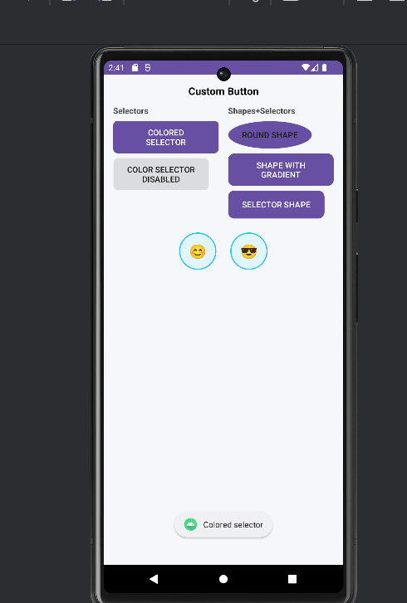
Bài tập 2:
Bước 1: Dựa theo bài tập 1, ta sẽ làm nút để chuyển tab sang bài 2, ta thêm nút dưới layout bài 1
<Button
android:id="@+id/btnOpenExercise2"
android:text="Sang Bài 2: Custom Toast và Dialog"
android:layout_marginTop="16dp"
android:layout_width="match_parent"
android:layout_height="wrap_content"/>

Bước 2: Ta phải bắt sự kiện để mở bài 2 trong MainActivity.java
Button btnOpenExercise2 = findViewById(R.id.btnOpenExercise2);
btnOpenExercise2.setOnClickListener(v ->
startActivity(new Intent(MainActivity.this, CustomNotifyActivity.class))
);

Bước 3: Ta tạo activity mới cho bài 2 CustomNotifyActivity
package com.example.projectlab7;
import android.os.Bundle;
import android.view.Gravity;
import android.view.LayoutInflater;
import android.view.View;
import android.widget.Button;
import android.widget.TextView;
import android.widget.Toast;
import androidx.appcompat.app.AlertDialog;
import androidx.appcompat.app.AppCompatActivity;
public class CustomNotifyActivity extends AppCompatActivity {
@Override
protected void onCreate(Bundle savedInstanceState) {
super.onCreate(savedInstanceState);
setContentView(R.layout.activity_custom_notify);
Button btnToast = findViewById(R.id.btnShowToast);
Button btnDialog = findViewById(R.id.btnShowDialog);
Button btnBack = findViewById(R.id.btnBackToBai1);
btnToast.setOnClickListener(v -> showCustomToast("Thành công!", "Đây là Custom Toast minh hoạ."));
btnDialog.setOnClickListener(v -> showCustomDialog());
btnBack.setOnClickListener(v -> finish());
}
private void showCustomToast(String title, String message) {
// inflate layout custom_toast
View toastView = LayoutInflater.from(this).inflate(R.layout.view_custom_toast, null);
TextView tvTitle = toastView.findViewById(R.id.tvToastTitle);
TextView tvMsg = toastView.findViewById(R.id.tvToastMsg);
tvTitle.setText(title);
tvMsg.setText(message);
Toast t = new Toast(this);
t.setView(toastView);
t.setDuration(Toast.LENGTH_LONG);
t.setGravity(Gravity.TOP | Gravity.FILL_HORIZONTAL, 0, 120); // giống demo: hiện phía trên
t.show();
}
private void showCustomDialog() {
// inflate layout custom_dialog
View dialogView = LayoutInflater.from(this).inflate(R.layout.view_custom_dialog, null);
TextView tvTitle = dialogView.findViewById(R.id.tvDlgTitle);
TextView tvMsg = dialogView.findViewById(R.id.tvDlgMsg);
tvTitle.setText("Xác nhận");
tvMsg.setText("Bạn có muốn thực hiện thao tác này không?");
AlertDialog dlg = new AlertDialog.Builder(this)
.setView(dialogView)
.setCancelable(false) // theo video tham chiếu thường không cho bấm ngoài để tắt
.create();
// Nút trong layout custom
dialogView.findViewById(R.id.btnDlgOk).setOnClickListener(v -> {
showCustomToast("OK", "Bạn đã xác nhận!");
dlg.dismiss();
});
dialogView.findViewById(R.id.btnDlgCancel).setOnClickListener(v -> {
showCustomToast("Huỷ", "Bạn đã huỷ thao tác.");
dlg.dismiss();
});
dlg.show();
}
}

Bước 4: Tạo giao diện cho bài 2 ở file app/src/main/res/layout/activity_custom_notify.xml
<?xml version="1.0" encoding="utf-8"?>
<LinearLayout xmlns:android="http://schemas.android.com/apk/res/android"
android:orientation="vertical"
android:padding="16dp"
android:gravity="center_horizontal"
android:layout_width="match_parent"
android:layout_height="match_parent">
<TextView
android:text="Bài 2: Custom Toast và Custom Dialog"
android:textStyle="bold"
android:textSize="18sp"
android:layout_width="wrap_content"
android:layout_height="wrap_content"/>
<Button
android:id="@+id/btnShowToast"
android:text="Hiện Custom Toast"
android:layout_marginTop="24dp"
android:layout_width="match_parent"
android:layout_height="wrap_content"/>
<Button
android:id="@+id/btnShowDialog"
android:text="Hiện Custom Dialog"
android:layout_marginTop="12dp"
android:layout_width="match_parent"
android:layout_height="wrap_content"/>
<Button
android:id="@+id/btnBackToBai1"
android:text="Quay về Bài 1"
android:layout_marginTop="24dp"
android:layout_width="match_parent"
android:layout_height="wrap_content"/>
</LinearLayout>

Bước 5: Ta tạo Layout Custom Toast trong file view_custom_toast.xml
<?xml version="1.0" encoding="utf-8"?>
<LinearLayout xmlns:android="http://schemas.android.com/apk/res/android"
android:orientation="horizontal"
android:background="@drawable/bg_toast"
android:padding="12dp"
android:gravity="center_vertical"
android:layout_width="match_parent"
android:layout_height="wrap_content">
<TextView
android:text="✅"
android:textSize="22sp"
android:layout_marginEnd="12dp"
android:layout_width="wrap_content"
android:layout_height="wrap_content"/>
<LinearLayout
android:orientation="vertical"
android:layout_width="0dp"
android:layout_height="wrap_content"
android:layout_weight="1">
<TextView
android:id="@+id/tvToastTitle"
android:text="Tiêu đề"
android:textStyle="bold"
android:textColor="#FFFFFF"
android:textSize="16sp"
android:layout_width="wrap_content"
android:layout_height="wrap_content"/>
<TextView
android:id="@+id/tvToastMsg"
android:text="Nội dung mô tả ngắn..."
android:textColor="#F0FFFFFF"
android:layout_width="wrap_content"
android:layout_height="wrap_content"/>
</LinearLayout>
</LinearLayout>

Bước 6: Ta tạo Layout Custom Dialog trong file view_custom_dialog.xml
<?xml version="1.0" encoding="utf-8"?>
<LinearLayout xmlns:android="http://schemas.android.com/apk/res/android"
android:orientation="vertical"
android:padding="16dp"
android:background="@drawable/bg_dialog"
android:layout_width="match_parent"
android:layout_height="wrap_content">
<TextView
android:id="@+id/tvDlgTitle"
android:text="Tiêu đề"
android:textStyle="bold"
android:textSize="18sp"
android:layout_width="match_parent"
android:layout_height="wrap_content"/>
<TextView
android:id="@+id/tvDlgMsg"
android:text="Nội dung thông báo..."
android:layout_marginTop="8dp"
android:layout_width="match_parent"
android:layout_height="wrap_content"/>
<LinearLayout
android:orientation="horizontal"
android:gravity="end"
android:layout_marginTop="16dp"
android:layout_width="match_parent"
android:layout_height="wrap_content">
<Button
android:id="@+id/btnDlgCancel"
android:text="Huỷ"
android:layout_width="wrap_content"
android:layout_height="wrap_content"/>
<Button
android:id="@+id/btnDlgOk"
android:text="OK"
android:layout_marginStart="12dp"
android:layout_width="wrap_content"
android:layout_height="wrap_content"/>
</LinearLayout>
</LinearLayout>

Bước 7: Ta tạo 2 file Drawable bo góc cho Toast và Dialog
- app/src/main/res/drawable/bg_toast.xml
<shape xmlns:android="http://schemas.android.com/apk/res/android">
<corners android:radius="12dp"/>
<solid android:color="#CC323232"/>
<padding android:left="12dp" android:top="10dp" android:right="12dp" android:bottom="10dp"/>
</shape>

- app/src/main/res/drawable/bg_dialog.xml
<shape xmlns:android="http://schemas.android.com/apk/res/android">
<corners android:radius="16dp"/>
<solid android:color="#FFFFFFFF"/>
<stroke android:width="1dp" android:color="#22000000"/>
<padding android:left="12dp" android:top="12dp" android:right="12dp" android:bottom="12dp"/>
</shape>

Bước 8: Ta khai báo Activity trong AndroidManifest.xml
<activity android:name=".CustomNotifyActivity" android:exported="false" />

Bước 9: Sau khi lại dự án, khi click vào các ô button như ô “Hiện Custom Toast “ thì sẽ hiện như hình bên dưới đây
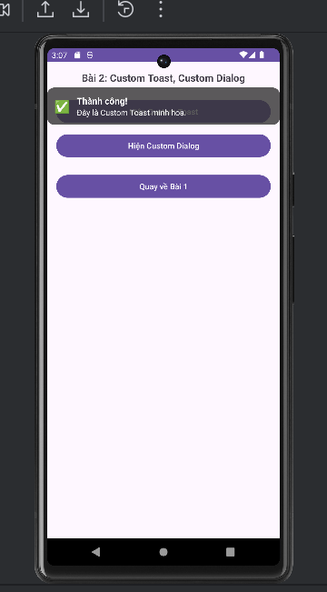
Bài tập 3:
Bước 1: Ta tạo thêm nút để chuyển sang các bài tập khác
<Button
android:id="@+id/btnOpenExercise3"
android:text="Sang Bài 3: RGB và CMY"
android:layout_marginTop="12dp"
android:layout_width="match_parent"
android:layout_height="wrap_content"/>

Bước 2: Ta bắt sự kiện mở bài 3 ở phần MainActivity.java
Button btnOpenExercise3 = findViewById(R.id.btnOpenExercise3);
btnOpenExercise3.setOnClickListener(v ->
startActivity(new Intent(MainActivity.this, ColorPickerActivity.class))
);

Bước 3: Ta thêm khai báo Activity mới trong Manifest
<activity android:name=".ColorPickerActivity" android:exported="false" />

Bước 4: Tạo layout cho bài 3 res/layout/activity_color_picker.xml
<?xml version="1.0" encoding="utf-8"?>
<LinearLayout xmlns:android="http://schemas.android.com/apk/res/android"
android:orientation="vertical"
android:padding="16dp"
android:layout_width="match_parent"
android:layout_height="match_parent">
<TextView
android:text="Bài 3: Chọn màu RGB , Tính CMY"
android:textStyle="bold"
android:textSize="18sp"
android:layout_width="wrap_content"
android:layout_height="wrap_content"/>
<!-- Khung xem trước màu -->
<View
android:id="@+id/viewPreview"
android:layout_marginTop="16dp"
android:layout_width="match_parent"
android:layout_height="120dp"
android:background="@drawable/bg_color_preview"/>
<!-- Giá trị hiển thị -->
<TextView
android:id="@+id/tvRgb"
android:text="RGB(0, 0, 0) | HEX #000000"
android:layout_marginTop="8dp"
android:textSize="16sp"
android:layout_width="match_parent"
android:layout_height="wrap_content"/>
<TextView
android:id="@+id/tvCmy"
android:text="CMY(255, 255, 255)"
android:layout_marginTop="4dp"
android:textSize="16sp"
android:layout_width="match_parent"
android:layout_height="wrap_content"/>
<!-- SeekBar R -->
<TextView
android:text="R:"
android:textStyle="bold"
android:layout_marginTop="16dp"
android:layout_width="wrap_content"
android:layout_height="wrap_content"/>
<LinearLayout
android:orientation="horizontal"
android:layout_width="match_parent"
android:layout_height="wrap_content">
<SeekBar
android:id="@+id/seekR"
android:max="255"
android:layout_width="0dp"
android:layout_height="wrap_content"
android:layout_weight="1"/>
<TextView
android:id="@+id/tvRVal"
android:text="0"
android:layout_marginStart="8dp"
android:layout_width="40dp"
android:layout_height="wrap_content"/>
</LinearLayout>
<!-- SeekBar G -->
<TextView
android:text="G:"
android:textStyle="bold"
android:layout_marginTop="8dp"
android:layout_width="wrap_content"
android:layout_height="wrap_content"/>
<LinearLayout
android:orientation="horizontal"
android:layout_width="match_parent"
android:layout_height="wrap_content">
<SeekBar
android:id="@+id/seekG"
android:max="255"
android:layout_width="0dp"
android:layout_height="wrap_content"
android:layout_weight="1"/>
<TextView
android:id="@+id/tvGVal"
android:text="0"
android:layout_marginStart="8dp"
android:layout_width="40dp"
android:layout_height="wrap_content"/>
</LinearLayout>
<!-- SeekBar B -->
<TextView
android:text="B:"
android:textStyle="bold"
android:layout_marginTop="8dp"
android:layout_width="wrap_content"
android:layout_height="wrap_content"/>
<LinearLayout
android:orientation="horizontal"
android:layout_width="match_parent"
android:layout_height="wrap_content">
<SeekBar
android:id="@+id/seekB"
android:max="255"
android:layout_width="0dp"
android:layout_height="wrap_content"
android:layout_weight="1"/>
<TextView
android:id="@+id/tvBVal"
android:text="0"
android:layout_marginStart="8dp"
android:layout_width="40dp"
android:layout_height="wrap_content"/>
</LinearLayout>
<!-- Nút chuyển bài -->
<LinearLayout
android:orientation="horizontal"
android:layout_marginTop="16dp"
android:layout_width="match_parent"
android:layout_height="wrap_content">
<Button
android:id="@+id/btnBackBai1"
android:text="Về Bài 1"
android:layout_width="0dp"
android:layout_height="wrap_content"
android:layout_weight="1"/>
<View
android:layout_width="12dp"
android:layout_height="1dp"/>
<Button
android:id="@+id/btnGotoBai2"
android:text="Sang Bài 2"
android:layout_width="0dp"
android:layout_height="wrap_content"
android:layout_weight="1"/>
</LinearLayout>
</LinearLayout>

Bước 5: Ta tạo tạo viền cho khung preview res/drawable/bg_color_preview.xml
<?xml version="1.0" encoding="utf-8"?>
<shape xmlns:android="http://schemas.android.com/apk/res/android">
<corners android:radius="12dp"/>
<solid android:color="#FFFFFFFF"/>
<stroke android:width="2dp" android:color="#22000000"/>
</shape>

Bước 6: Ta xử lý code logic tại ColorPickerActivity.java
package com.example.projectlab7;
import android.content.Intent;
import android.graphics.Color;
import android.os.Bundle;
import android.widget.Button;
import android.widget.SeekBar;
import android.widget.TextView;
import android.view.View;
import androidx.appcompat.app.AppCompatActivity;
public class ColorPickerActivity extends AppCompatActivity {
private View viewPreview;
private SeekBar seekR, seekG, seekB;
private TextView tvRVal, tvGVal, tvBVal, tvRgb, tvCmy;
@Override
protected void onCreate(Bundle savedInstanceState) {
super.onCreate(savedInstanceState);
setContentView(R.layout.activity_color_picker);
mapViews();
setupSeekbars(64, 128, 192); // giá trị khởi đầu (tuỳ chọn)
bindNavButtons();
}
private void mapViews() {
viewPreview = findViewById(R.id.viewPreview);
seekR = findViewById(R.id.seekR);
seekG = findViewById(R.id.seekG);
seekB = findViewById(R.id.seekB);
tvRVal = findViewById(R.id.tvRVal);
tvGVal = findViewById(R.id.tvGVal);
tvBVal = findViewById(R.id.tvBVal);
tvRgb = findViewById(R.id.tvRgb);
tvCmy = findViewById(R.id.tvCmy);
Button btnBackBai1 = findViewById(R.id.btnBackBai1);
Button btnGotoBai2 = findViewById(R.id.btnGotoBai2);
btnBackBai1.setOnClickListener(v -> finish()); // quay về Bài 1 (MainActivity)
btnGotoBai2.setOnClickListener(v ->
startActivity(new Intent(ColorPickerActivity.this, CustomNotifyActivity.class))
);
}
private void setupSeekbars(int r0, int g0, int b0) {
seekR.setMax(255);
seekG.setMax(255);
seekB.setMax(255);
seekR.setProgress(r0);
seekG.setProgress(g0);
seekB.setProgress(b0);
SeekBar.OnSeekBarChangeListener listener = new SeekBar.OnSeekBarChangeListener() {
@Override public void onProgressChanged(SeekBar seekBar, int progress, boolean fromUser) { updateColor(); }
@Override public void onStartTrackingTouch(SeekBar seekBar) { }
@Override public void onStopTrackingTouch(SeekBar seekBar) { }
};
seekR.setOnSeekBarChangeListener(listener);
seekG.setOnSeekBarChangeListener(listener);
seekB.setOnSeekBarChangeListener(listener);
updateColor(); // render lần đầu
}
private void updateColor() {
int r = seekR.getProgress();
int g = seekG.getProgress();
int b = seekB.getProgress();
tvRVal.setText(String.valueOf(r));
tvGVal.setText(String.valueOf(g));
tvBVal.setText(String.valueOf(b));
// cập nhật màu preview
int color = Color.rgb(r, g, b);
viewPreview.setBackgroundColor(color);
// RGB + HEX
String hex = String.format("#%02X%02X%02X", r, g, b);
tvRgb.setText("RGB(" + r + ", " + g + ", " + b + ") | HEX " + hex);
// CMY = 255 - RGB
int c = 255 - r;
int m = 255 - g;
int y = 255 - b;
tvCmy.setText("CMY(" + c + ", " + m + ", " + y + ")");
}
private void bindNavButtons() {
// Đã bind trong mapViews() — tách riêng cho dễ nhìn; không cần thêm gì nữa.
}
}

Bước 7: Khi chạy dự án thành công, ta sẽ có giao như hình, khi ta kéo cái các mục R G B tại một mức nhất định, khi màn hình sẽ hiện ra các dải màu tương ứng
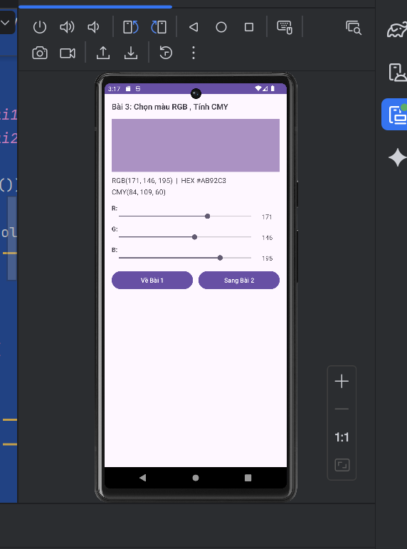
LAB 8: List trong Android
Phần Bài Tập
Bài tập 1:
Bước 1: Ta tạo một dự án mới tên là ProjectLab8
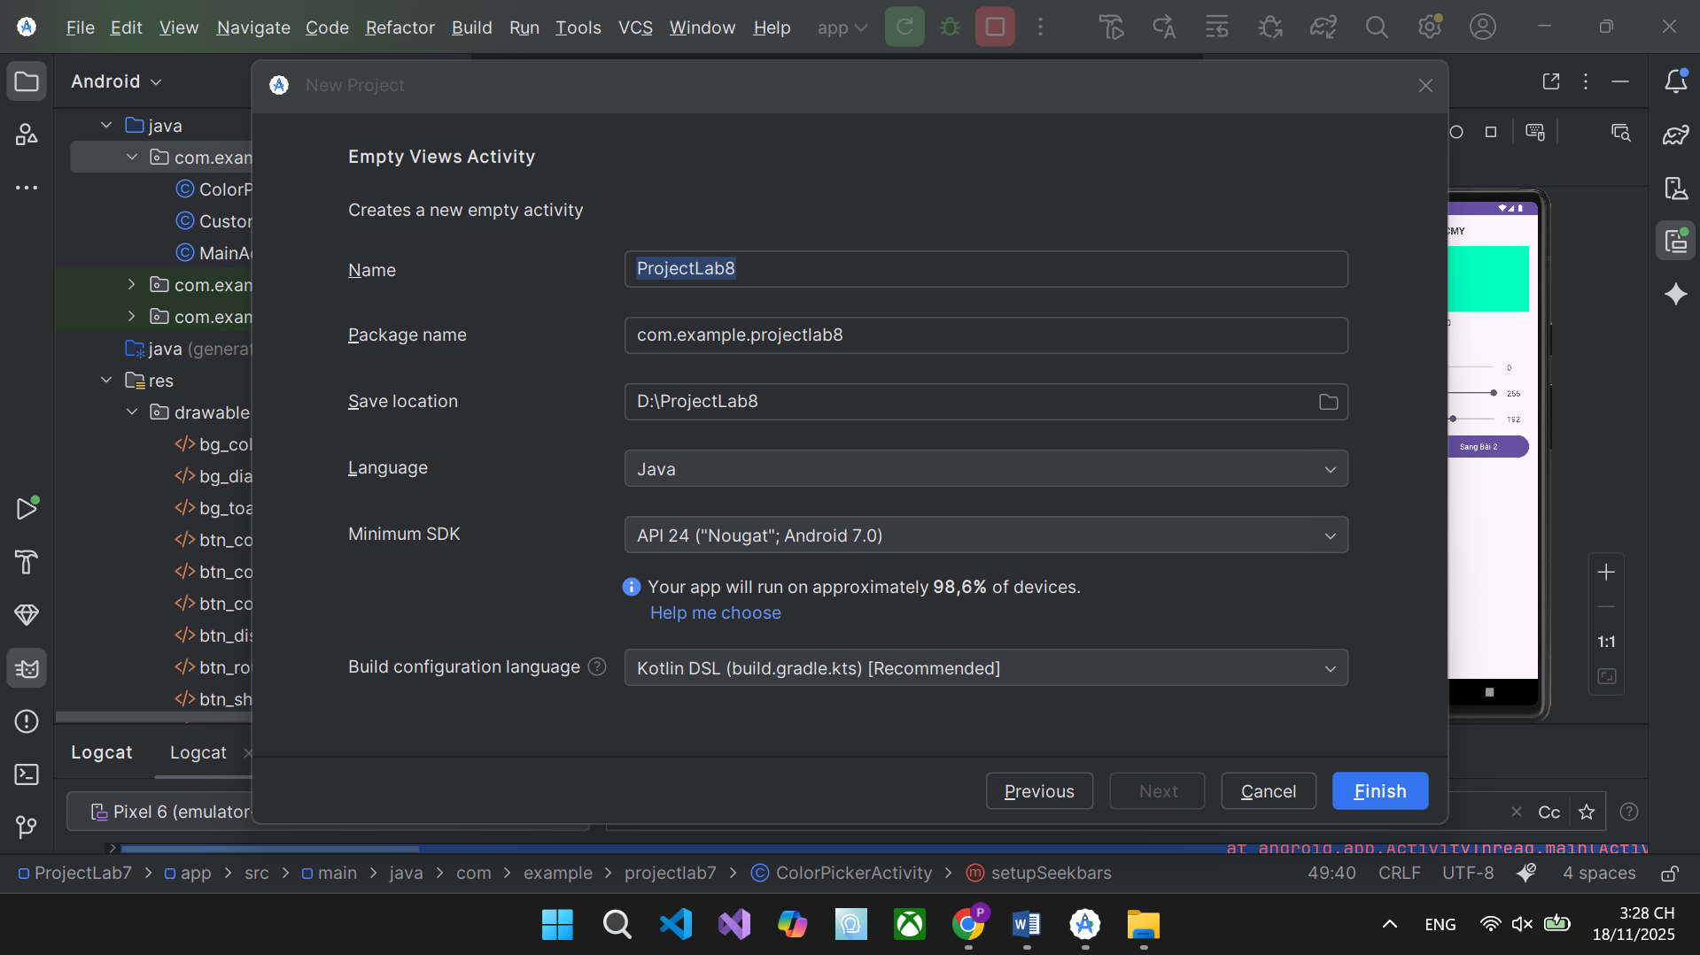
Bước 2: Ta thiết kế giao diện cho bài tập 1 activity_main.xml, xóa đoạn code trong đó và thay bằng đoạn code mới dưới đây
<?xml version="1.0" encoding="utf-8"?>
<LinearLayout xmlns:android="http://schemas.android.com/apk/res/android"
android:layout_width="match_parent"
android:layout_height="match_parent"
android:orientation="vertical"
android:padding="16dp">
<!-- TextView hiển thị thông tin khi click -->
<TextView
android:id="@+id/txtInfo"
android:layout_width="match_parent"
android:layout_height="wrap_content"
android:text="Chọn một món ăn để xem chi tiết"
android:textSize="16sp"
android:textStyle="italic"
android:padding="10dp"
android:background="#FFF3E0"
android:layout_marginBottom="10dp"/>
<!-- ListView hiển thị danh sách món ăn -->
<ListView
android:id="@+id/listViewMonAn"
android:layout_width="match_parent"
android:layout_height="match_parent"/>
</LinearLayout>

Bước 3: Ta tạo mỗi layout cho mỗi dòng listview bằng file res/layout/row_item.xml
<?xml version="1.0" encoding="utf-8"?>
<LinearLayout xmlns:android="http://schemas.android.com/apk/res/android"
android:layout_width="match_parent"
android:layout_height="wrap_content"
android:orientation="horizontal"
android:padding="8dp">
<!-- Hình ảnh món ăn -->
<ImageView
android:id="@+id/imgMonAn"
android:layout_width="80dp"
android:layout_height="80dp"
android:scaleType="centerCrop"
android:src="@drawable/ic_pho"/>
<!-- Phần thông tin bên phải -->
<LinearLayout
android:layout_width="0dp"
android:layout_height="wrap_content"
android:layout_weight="1"
android:orientation="vertical"
android:layout_marginStart="12dp">
<!-- Tên món -->
<TextView
android:id="@+id/txtTenMon"
android:layout_width="match_parent"
android:layout_height="wrap_content"
android:text="Phở bò"
android:textSize="18sp"
android:textStyle="bold"
android:textColor="#D81B60"/>
<!-- Giá tiền -->
<TextView
android:id="@+id/txtGia"
android:layout_width="match_parent"
android:layout_height="wrap_content"
android:text="45.000 đ"
android:textSize="16sp"
android:textColor="#2E7D32"
android:layout_marginTop="4dp"/>
<!-- Mô tả -->
<TextView
android:id="@+id/txtMoTa"
android:layout_width="match_parent"
android:layout_height="wrap_content"
android:text="Phở bò truyền thống với nước dùng trong, thơm"
android:textSize="14sp"
android:textColor="#555555"
android:layout_marginTop="4dp"
android:maxLines="2"
android:ellipsize="end"/>
</LinearLayout>
</LinearLayout>

Bước 4: Ta tải hình ảnh các món ăn
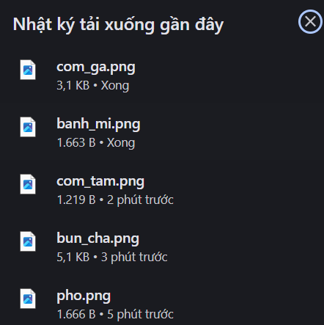
Bước 5: Ta kéo các hình vào file app/src/main/res/drawable
Bước 6: Ta xử lý code logic trong file MonAn.java
package com.example.projectlab8;
public class MonAn {
private String tenMon;
private int gia;
private String moTa;
private int hinhAnh; // resource ID
public MonAn(String tenMon, int gia, String moTa, int hinhAnh) {
this.tenMon = tenMon;
this.gia = gia;
this.moTa = moTa;
this.hinhAnh = hinhAnh;
}
public String getTenMon() { return tenMon; }
public int getGia() { return gia; }
public String getMoTa() { return moTa; }
public int getHinhAnh() { return hinhAnh; }
@Override
public String toString() {
return tenMon + " - " + gia + "đ";
}
}

Bước 7: Ta tạo adapter tùy chỉnh trong file MonAnAdapter.java
package com.example.projectlab8;
import android.content.Context;
import android.view.LayoutInflater;
import android.view.View;
import android.view.ViewGroup;
import android.widget.BaseAdapter;
import android.widget.ImageView;
import android.widget.TextView;
import java.text.NumberFormat;
import java.util.List;
import java.util.Locale;
public class MonAnAdapter extends BaseAdapter {
private Context context;
private List<MonAn> list;
public MonAnAdapter(Context context, List<MonAn> list) {
this.context = context;
this.list = list;
}
@Override
public int getCount() { return list.size(); }
@Override
public Object getItem(int position) { return list.get(position); }
@Override
public long getItemId(int position) { return position; }
@Override
public View getView(int position, View convertView, ViewGroup parent) {
if (convertView == null) {
convertView = LayoutInflater.from(context).inflate(R.layout.row_item, parent, false);
}
// Ánh xạ view
ImageView imgMonAn = convertView.findViewById(R.id.imgMonAn);
TextView txtTenMon = convertView.findViewById(R.id.txtTenMon);
TextView txtGia = convertView.findViewById(R.id.txtGia);
TextView txtMoTa = convertView.findViewById(R.id.txtMoTa);
// Lấy dữ liệu
MonAn monAn = list.get(position);
// Gán dữ liệu
imgMonAn.setImageResource(monAn.getHinhAnh());
txtTenMon.setText(monAn.getTenMon());
txtMoTa.setText(monAn.getMoTa());
// Định dạng giá tiền
NumberFormat formatter = NumberFormat.getCurrencyInstance(new Locale("vi", "VN"));
String giaTien = formatter.format(monAn.getGia()).replace("₫", "đ");
txtGia.setText(giaTien);
return convertView;
}
}

Bước 8: Ta xóa hết đoạn code cũ trong MainActivity và dán đoạn code bên dưới đây
package com.example.projectlab8;
import android.os.Bundle;
import android.view.View;
import android.widget.AdapterView;
import android.widget.ListView;
import android.widget.TextView;
import androidx.appcompat.app.AppCompatActivity;
import java.util.ArrayList;
public class MainActivity extends AppCompatActivity {
private ListView listView;
private TextView txtInfo;
private ArrayList<MonAn> danhSachMonAn;
private MonAnAdapter adapter;
@Override
protected void onCreate(Bundle savedInstanceState) {
super.onCreate(savedInstanceState);
setContentView(R.layout.activity_main);
// Ánh xạ
listView = findViewById(R.id.listViewMonAn);
txtInfo = findViewById(R.id.txtInfo);
// Chuẩn bị dữ liệu
danhSachMonAn = new ArrayList<>();
danhSachMonAn.add(new MonAn("Phở bò", 45000, "Nước dùng trong, thịt bò mềm", R.drawable.pho));
danhSachMonAn.add(new MonAn("Bún chả", 50000, "Thịt nướng thơm, nước mắm chua ngọt", R.drawable.bun_cha));
danhSachMonAn.add(new MonAn("Cơm tấm", 40000, "Sườn nướng, bì, chả trứng", R.drawable.com_tam));
danhSachMonAn.add(new MonAn("Bánh mì", 25000, "Pate, thịt, dưa chua, rau thơm", R.drawable.banh_mi));
danhSachMonAn.add(new MonAn("Cơm gà", 35000, "Gà ta luộc, cơm dẻo", R.drawable.com_ga));
// Tạo adapter
adapter = new MonAnAdapter(this, danhSachMonAn);
listView.setAdapter(adapter);
// Xử lý click
listView.setOnItemClickListener(new AdapterView.OnItemClickListener() {
@Override
public void onItemClick(AdapterView<?> parent, View view, int position, long id) {
MonAn mon = danhSachMonAn.get(position);
txtInfo.setText("Bạn chọn: " + mon.getTenMon() +
"\nGiá: " + mon.getGia() + "đ" +
"\nMô tả: " + mon.getMoTa());
}
});
}
}

Bước 9: Sau khi chạy dự án thành công, sẽ hiện thị ra danh sách các món ăn cùng với hình ảnh mà ta vừa thêm vào, khi click vào 1 món bất kì sẽ hiện ra giá tiền và mô tả
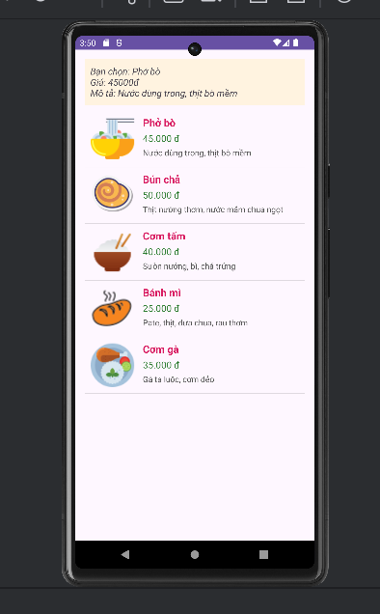
Bài tập 2:
Bước 1: Ta tạo thêm 1 nút ở bài 1 để chuyển đổi sang bài , thay đoạn code activity.xml bằng đoạn dưới đây
<?xml version="1.0" encoding="utf-8"?>
<RelativeLayout xmlns:android="http://schemas.android.com/apk/res/android"
android:layout_width="match_parent"
android:layout_height="match_parent">
<!-- TextView hiển thị thông tin khi click -->
<TextView
android:id="@+id/txtInfo"
android:layout_width="match_parent"
android:layout_height="wrap_content"
android:text="Chọn một món ăn để xem chi tiết"
android:textSize="16sp"
android:textStyle="italic"
android:padding="12dp"
android:background="#FFF3E0"
android:layout_alignParentTop="true"/>
<!-- Nút chuyển đổi ListView ↔ GridView -->
<Button
android:id="@+id/btnSwitch"
android:layout_width="wrap_content"
android:layout_height="wrap_content"
android:text="⇄ GridView"
android:textSize="14sp"
android:backgroundTint="#FF9800"
android:layout_alignParentEnd="true"
android:layout_alignParentTop="true"
android:layout_margin="8dp"/>
<!-- FrameLayout để chứa ListView hoặc GridView -->
<FrameLayout
android:id="@+id/container"
android:layout_width="match_parent"
android:layout_height="match_parent"
android:layout_below="@id/txtInfo"/>
</RelativeLayout>

Bước 2: Tạo 2 layout riêng cho listview và gridview
- res/layout/layout_listview.xml
<?xml version="1.0" encoding="utf-8"?>
<ListView xmlns:android="http://schemas.android.com/apk/res/android"
android:id="@+id/listView"
android:layout_width="match_parent"
android:layout_height="match_parent"/>

- res/layout/layout_ gridview.xml
<?xml version="1.0" encoding="utf-8"?>
<GridView xmlns:android="http://schemas.android.com/apk/res/android"
android:id="@+id/gridView"
android:layout_width="match_parent"
android:layout_height="match_parent"
android:numColumns="2"
android:columnWidth="160dp"
android:stretchMode="columnWidth"
android:horizontalSpacing="12dp"
android:verticalSpacing="12dp"
android:padding="8dp"/>

Bước 3: Ta sửa lại phần code ở MainActivity như code bên dưới đây
package com.example.projectlab8;
import android.os.Bundle;
import android.view.View;
import android.widget.AdapterView;
import android.widget.Button;
import android.widget.FrameLayout;
import android.widget.GridView;
import android.widget.ListView;
import android.widget.TextView;
import androidx.appcompat.app.AppCompatActivity;
import java.util.ArrayList;
public class MainActivity extends AppCompatActivity {
private FrameLayout container;
private ListView listView;
private GridView gridView;
private TextView txtInfo;
private Button btnSwitch;
private ArrayList<MonAn> danhSachMonAn;
private MonAnAdapter adapter;
private boolean isGridView = false; // false = ListView, true = GridView
@Override
protected void onCreate(Bundle savedInstanceState) {
super.onCreate(savedInstanceState);
setContentView(R.layout.activity_main);
txtInfo = findViewById(R.id.txtInfo);
btnSwitch = findViewById(R.id.btnSwitch);
container = findViewById(R.id.container);
// Chuẩn bị dữ liệu
danhSachMonAn = new ArrayList<>();
danhSachMonAn.add(new MonAn("Phở bò", 45000, "Nước dùng trong, thịt bò mềm", R.drawable.pho));
danhSachMonAn.add(new MonAn("Bún chả", 50000, "Thịt nướng thơm lừng", R.drawable.bun_cha));
danhSachMonAn.add(new MonAn("Cơm tấm", 40000, "Sườn nướng, bì, chả", R.drawable.com_tam));
danhSachMonAn.add(new MonAn("Bánh mì", 25000, "Pate, thịt nướng", R.drawable.banh_mi));
danhSachMonAn.add(new MonAn("Cơm gà", 35000, "Gà ta luộc", R.drawable.com_ga));
adapter = new MonAnAdapter(this, danhSachMonAn);
// Mặc định hiển thị ListView
showListView();
// Xử lý nút chuyển đổi
btnSwitch.setOnClickListener(v -> {
if (isGridView) {
showListView();
btnSwitch.setText("⇄ GridView");
} else {
showGridView();
btnSwitch.setText("⇄ ListView");
}
isGridView = !isGridView;
});
}
private void showListView() {
container.removeAllViews();
View view = getLayoutInflater().inflate(R.layout.layout_listview, container, false);
listView = view.findViewById(R.id.listView);
listView.setAdapter(adapter);
listView.setOnItemClickListener((parent, view1, position, id) -> {
MonAn mon = danhSachMonAn.get(position);
txtInfo.setText("BÀI 1 - ListView\n" + mon.getTenMon() + " - " + mon.getGia() + "đ\n" + mon.getMoTa());
});
container.addView(view);
}
private void showGridView() {
container.removeAllViews();
View view = getLayoutInflater().inflate(R.layout.layout_gridview, container, false);
gridView = view.findViewById(R.id.gridView);
gridView.setAdapter(adapter);
gridView.setOnItemClickListener((parent, view1, position, id) -> {
MonAn mon = danhSachMonAn.get(position);
txtInfo.setText("BÀI 2 - GridView\nBạn chọn: " + mon.getTenMon() + " (" + mon.getGia() + "đ)");
});
container.addView(view);
}
}

Bước 4: Sau khi chạy dự án thành công, giao diện sẽ hiện ra danh sách món ăn theo dạng GridView, ta nhấn nút chuyển đổi sang ListView sẽ hiện thị như hình bên dưới
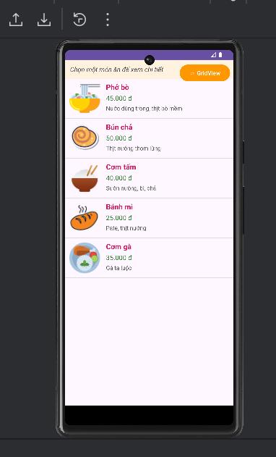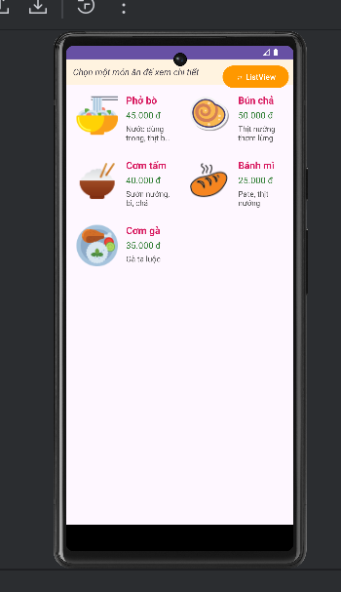
Bài 3:
Bước 1: Ta sẽ thêm vào file activity_main.xml để có 3 nút chuyển bài từ bài 1 sang bài 3
<?xml version="1.0" encoding="utf-8"?>
<LinearLayout xmlns:android="http://schemas.android.com/apk/res/android"
xmlns:app="http://schemas.android.com/apk/res-auto"
android:layout_width="match_parent"
android:layout_height="match_parent"
android:orientation="vertical">
<LinearLayout
android:id="@+id/header"
android:layout_width="match_parent"
android:layout_height="56dp"
android:orientation="horizontal"
android:background="#1976D2"
android:gravity="center_vertical"
android:paddingStart="16dp">
<TextView
android:id="@+id/txtTitle"
android:layout_width="0dp"
android:layout_weight="1"
android:layout_height="wrap_content"
android:text="BÀI 1 - Custom ListView"
android:textColor="#FFFFFF"
android:textSize="18sp"
android:textStyle="bold"/>
<ImageButton
android:id="@+id/btnAdd"
android:layout_width="48dp"
android:layout_height="48dp"
android:src="@android:drawable/ic_menu_add"
android:background="?attr/selectableItemBackgroundBorderless"
android:contentDescription="Thêm món"
app:tint="@android:color/white" />
</LinearLayout>
<TextView
android:id="@+id/txtInfo"
android:layout_width="match_parent"
android:layout_height="wrap_content"
android:text="Chọn một món ăn để xem chi tiết"
android:padding="12dp"
android:background="#E3F2FD"
android:textSize="15sp"/>
<FrameLayout
android:id="@+id/container"
android:layout_width="match_parent"
android:layout_height="0dp"
android:layout_weight="1"/>
<LinearLayout
android:layout_width="match_parent"
android:layout_height="wrap_content"
android:orientation="horizontal"
android:background="#212121">
<Button
android:id="@+id/btnListView"
android:layout_width="0dp"
android:layout_height="56dp"
android:layout_weight="1"
android:text="ListView"
android:textColor="#FFFFFF"
android:backgroundTint="#4CAF50"/>
<Button
android:id="@+id/btnGridView"
android:layout_width="0dp"
android:layout_height="56dp"
android:layout_weight="1"
android:text="GridView"
android:textColor="#FFFFFF"
android:backgroundTint="#FF9800"/>
<Button
android:id="@+id/btnQuanLy"
android:layout_width="0dp"
android:layout_height="56dp"
android:layout_weight="1"
android:text="Quản Lý"
android:textColor="#FFFFFF"
android:backgroundTint="#F44336"/>
</LinearLayout>
</LinearLayout>

Bước 2: Ta cập nhật lại file MainActivity.java
package com.example.projectlab8;
import android.os.Bundle;
import android.view.ContextMenu;
import android.view.MenuItem;
import android.view.View;
import android.widget.AdapterView;
import android.widget.Button;
import android.widget.EditText;
import android.widget.FrameLayout;
import android.widget.GridView;
import android.widget.ImageButton;
import android.widget.ListView;
import android.widget.TextView;
import android.widget.Toast;
import androidx.appcompat.app.AlertDialog;
import androidx.appcompat.app.AppCompatActivity;
import java.util.ArrayList;
public class MainActivity extends AppCompatActivity {
private FrameLayout container;
private ListView listView;
private GridView gridView;
private TextView txtInfo, txtTitle;
private ImageButton btnAdd;
private Button btnListView, btnGridView, btnQuanLy;
private ArrayList<MonAn> danhSach;
private MonAnAdapter adapter;
private int currentMode = 0; // 0:List 1:Grid 2:Quản lý
private int selectedPosition = -1;
@Override
protected void onCreate(Bundle savedInstanceState) {
super.onCreate(savedInstanceState);
setContentView(R.layout.activity_main);
anhXa();
khoiTaoDuLieu();
adapter = new MonAnAdapter(this, danhSach);
hienThiListView();
btnListView.setOnClickListener(v -> hienThiListView());
btnGridView.setOnClickListener(v -> hienThiGridView());
btnQuanLy.setOnClickListener(v -> hienThiQuanLy());
btnAdd.setOnClickListener(v -> themMonAn());
}
private void anhXa() {
container = findViewById(R.id.container);
txtInfo = findViewById(R.id.txtInfo);
txtTitle = findViewById(R.id.txtTitle);
btnAdd = findViewById(R.id.btnAdd);
btnListView = findViewById(R.id.btnListView);
btnGridView = findViewById(R.id.btnGridView);
btnQuanLy = findViewById(R.id.btnQuanLy);
}
private void khoiTaoDuLieu() {
danhSach = new ArrayList<>();
danhSach.add(new MonAn("Phở bò", 45000, "Nước dùng trong", R.drawable.pho));
danhSach.add(new MonAn("Bún chả", 50000, "Thịt nướng", R.drawable.bun_cha));
danhSach.add(new MonAn("Cơm tấm", 40000, "Sườn bì chả", R.drawable.com_tam));
danhSach.add(new MonAn("Bánh mì", 25000, "Pate thịt", R.drawable.banh_mi));
danhSach.add(new MonAn("Cơm gà", 35000, "Gà ta", R.drawable.com_ga));
}
private void capNhatTieuDe() {
if (currentMode == 0) txtTitle.setText("BÀI 1 - Custom ListView");
else if (currentMode == 1) txtTitle.setText("BÀI 2 - Custom GridView");
else txtTitle.setText("BÀI 3 - Quản Lý Món Ăn");
btnAdd.setVisibility(currentMode == 2 ? View.VISIBLE : View.GONE);
}
private void hienThiListView() {
currentMode = 0; capNhatTieuDe();
container.removeAllViews();
View v = getLayoutInflater().inflate(R.layout.layout_listview, container, false);
listView = v.findViewById(R.id.listView);
listView.setAdapter(adapter);
listView.setOnItemClickListener((p, view, pos, id) -> showInfo(pos));
container.addView(v);
}
private void hienThiGridView() {
currentMode = 1; capNhatTieuDe();
container.removeAllViews();
View v = getLayoutInflater().inflate(R.layout.layout_gridview, container, false);
gridView = v.findViewById(R.id.gridView);
gridView.setAdapter(adapter);
gridView.setOnItemClickListener((p, view, pos, id) -> showInfo(pos));
container.addView(v);
}
private void hienThiQuanLy() {
currentMode = 2; capNhatTieuDe();
container.removeAllViews();
View v = getLayoutInflater().inflate(R.layout.layout_listview, container, false);
listView = v.findViewById(R.id.listView);
listView.setAdapter(adapter);
registerForContextMenu(listView);
listView.setOnItemLongClickListener((p, view, pos, id) -> {
selectedPosition = pos;
return false;
});
listView.setOnItemClickListener((p, view, pos, id) -> showInfo(pos));
container.addView(v);
}
private void showInfo(int pos) {
MonAn m = danhSach.get(pos);
txtInfo.setText(m.getTenMon() + " - " + m.getGia() + "đ\n" + m.getMoTa());
}
// ContextMenu
@Override
public void onCreateContextMenu(ContextMenu menu, View v, ContextMenu.ContextMenuInfo menuInfo) {
super.onCreateContextMenu(menu, v, menuInfo);
if (currentMode == 2) {
getMenuInflater().inflate(R.menu.menu_context, menu);
}
}
@Override
public boolean onContextItemSelected(MenuItem item) {
if (currentMode != 2 || selectedPosition == -1) return super.onContextItemSelected(item);
if (item.getItemId() == R.id.menu_edit) {
suaMonAn(selectedPosition);
} else if (item.getItemId() == R.id.menu_delete) {
danhSach.remove(selectedPosition);
adapter.notifyDataSetChanged();
Toast.makeText(this, "Đã xóa!", Toast.LENGTH_SHORT).show();
}
return true;
}
private void themMonAn() {
AlertDialog.Builder builder = new AlertDialog.Builder(this);
builder.setTitle("Thêm món ăn");
View view = getLayoutInflater().inflate(R.layout.dialog, null);
EditText edtTen = view.findViewById(R.id.edtTen);
EditText edtGia = view.findViewById(R.id.edtGia);
EditText edtMoTa = view.findViewById(R.id.edtMoTa);
builder.setView(view);
builder.setPositiveButton("Thêm", (d, w) -> {
String ten = edtTen.getText().toString().trim();
String giaStr = edtGia.getText().toString().trim();
String moTa = edtMoTa.getText().toString().trim();
if (!ten.isEmpty() && !giaStr.isEmpty()) {
int gia = Integer.parseInt(giaStr);
danhSach.add(new MonAn(ten, gia, moTa, R.drawable.pho)); // tạm dùng hình phở
adapter.notifyDataSetChanged();
Toast.makeText(this, "Đã thêm!", Toast.LENGTH_SHORT).show();
}
});
builder.setNegativeButton("Hủy", null);
builder.show();
}
private void suaMonAn(int pos) {
MonAn m = danhSach.get(pos);
AlertDialog.Builder builder = new AlertDialog.Builder(this);
builder.setTitle("Sửa món ăn");
View view = getLayoutInflater().inflate(R.layout.dialog, null);
EditText edtTen = view.findViewById(R.id.edtTen);
EditText edtGia = view.findViewById(R.id.edtGia);
EditText edtMoTa = view.findViewById(R.id.edtMoTa);
edtTen.setText(m.getTenMon());
edtGia.setText(String.valueOf(m.getGia()));
edtMoTa.setText(m.getMoTa());
builder.setView(view);
builder.setPositiveButton("Lưu", (d, w) -> {
String ten = edtTen.getText().toString().trim();
String giaStr = edtGia.getText().toString().trim();
String moTa = edtMoTa.getText().toString().trim();
if (!ten.isEmpty() && !giaStr.isEmpty()) {
m.setTenMon(ten);
m.setGia(Integer.parseInt(giaStr));
m.setMoTa(moTa);
adapter.notifyDataSetChanged();
Toast.makeText(this, "Đã sửa!", Toast.LENGTH_SHORT).show();
}
});
builder.setNegativeButton("Hủy", null);
builder.show();
}
}

Bước 3: Ta chuột phải vào res chọn New tích Android Resource File đặt tên là menu_context.xml
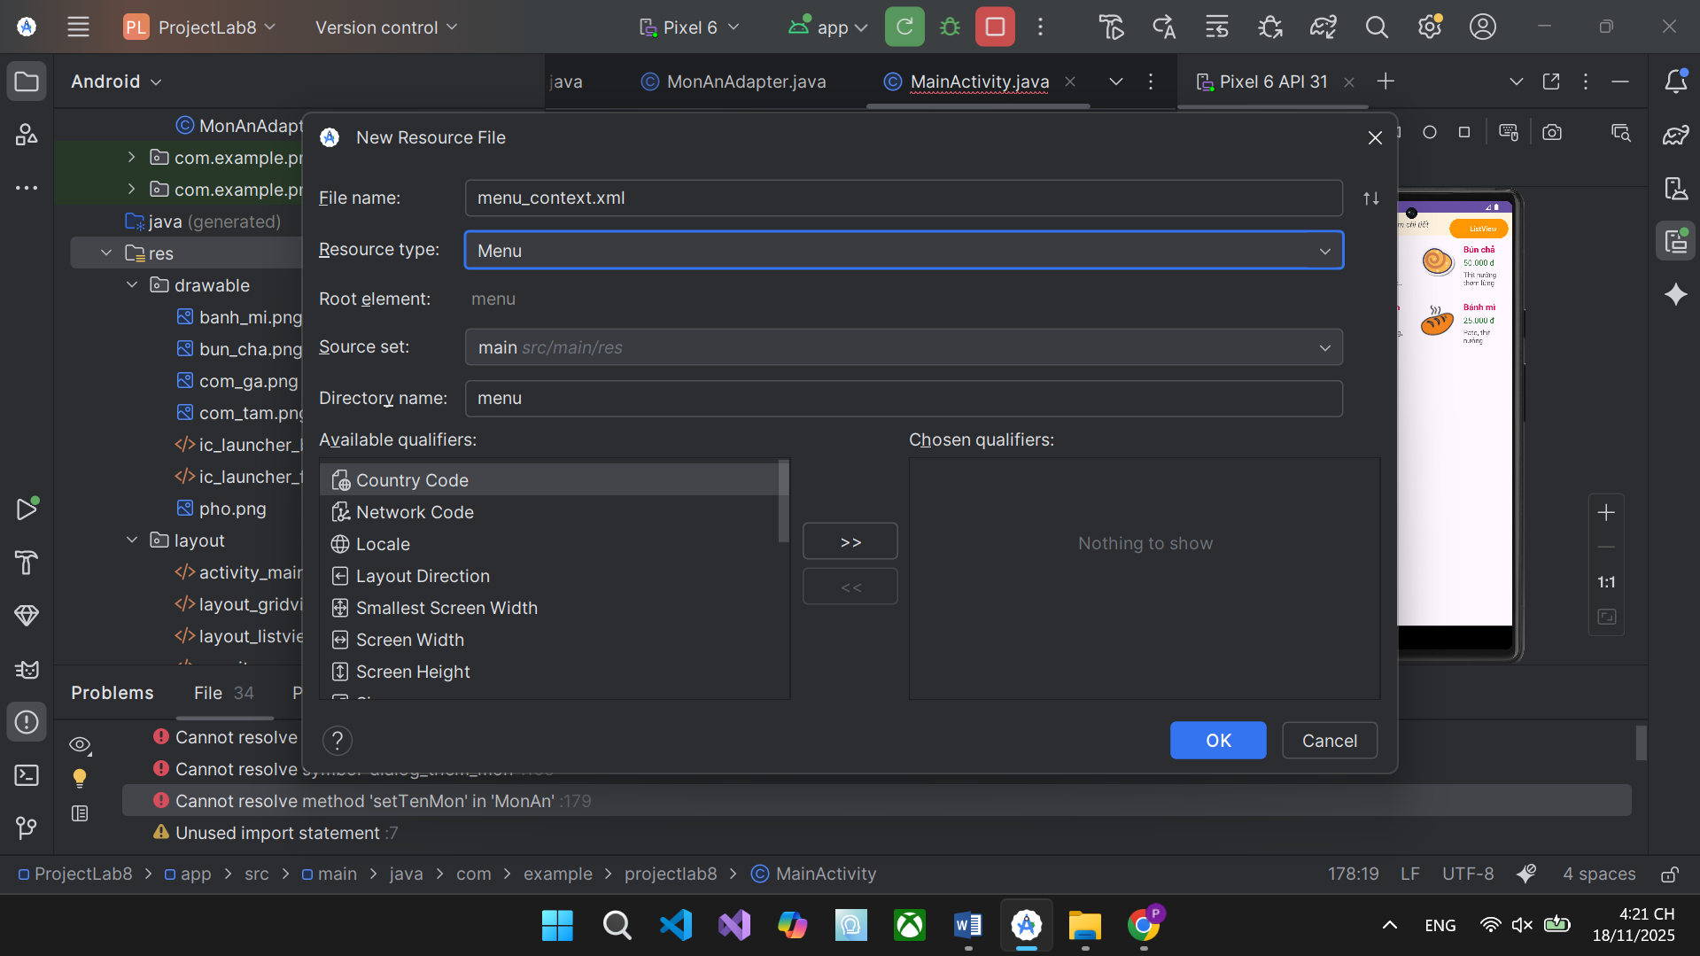
Ta dán đoạn code bên dưới vào
<?xml version="1.0" encoding="utf-8"?>
<menu xmlns:android="http://schemas.android.com/apk/res/android">
<item
android:id="@+id/menu_edit"
android:title="Sửa" />
<item
android:id="@+id/menu_delete"
android:title="Xóa" />
</menu>

Bước 4: Ta tạo tiếp file layout dialog.xml
<?xml version="1.0" encoding="utf-8"?>
<LinearLayout xmlns:android="http://schemas.android.com/apk/res/android"
android:layout_width="match_parent"
android:layout_height="wrap_content"
android:orientation="vertical"
android:padding="16dp">
<EditText
android:id="@+id/edtTen"
android:layout_width="match_parent"
android:layout_height="wrap_content"
android:hint="Tên món"/>
<EditText
android:id="@+id/edtGia"
android:layout_width="match_parent"
android:layout_height="wrap_content"
android:inputType="number"
android:hint="Giá"/>
<EditText
android:id="@+id/edtMoTa"
android:layout_width="match_parent"
android:layout_height="wrap_content"
android:hint="Mô tả"/>
</LinearLayout>

Bước 5: Sau khi chạy thành công dự án, ta sẽ thấy có 3 nút để chuyển sang 3 bài 1 2 3, click vào quản lý là bài 3, ta sẽ thấy danh sách, khi ta chạm chuột lâu vào 1 một bất kỳ sẽ hiện lên nút sửa và xóa
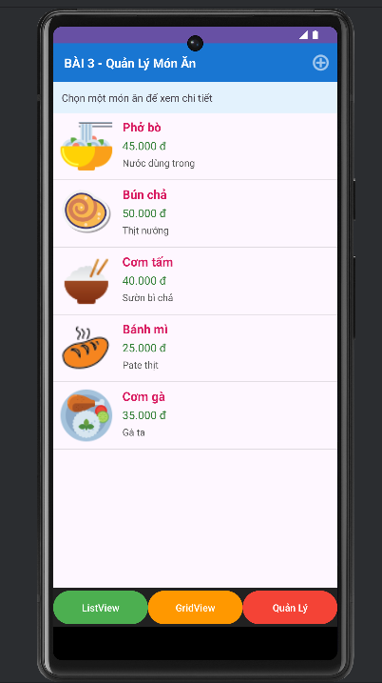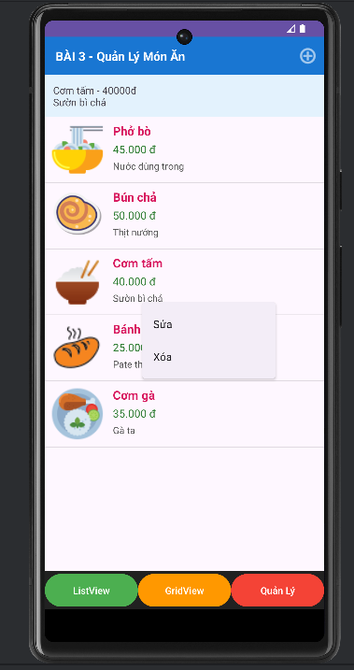
Nhấn vào sửa sẽ hiện ra giao diện như hình và ta sẽ thực hiện chức năng để sửa
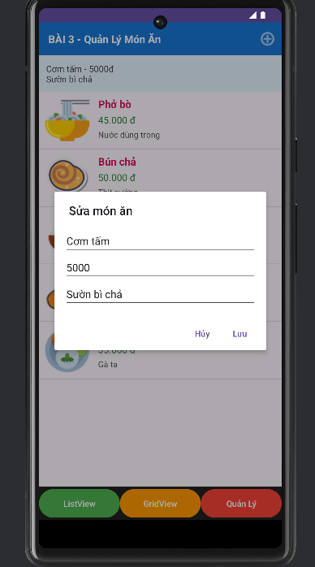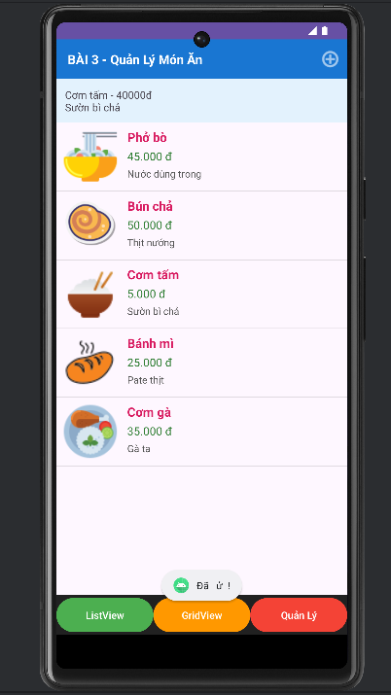
Nhấn vào nút xóa và ta thực hiện chức năng xóa
